Zippy the Frog perched on a moss-covered stone, his bright green skin flashing under the canopy. He had been chosen by the forest council as a decoy to divert predators from the burrow where the young chorus frogs hatched. The council had noted that frogs can release a toxin from their skin that deters many mammals; Zippy’s dorsal pattern mimicked this warning, causing a fox to pause and sniff at his flank, its tongue retracting. (Frogs secrete toxins through their skin as a defense mechanism.)
Zippy’s legs were long and powerful; a single leap could cover more than twice his own body length. (A frog’s hind legs are built for explosive jumps, enabling distances up to 20 times its length.) He launched himself toward a rustling bush, drawing the attention of the hungry weasel. While the weasel chased the rustle, the real chorus frogs hurried into the damp burrow, their eggs remaining safe. (Frogs rely on rapid movement and camouflage to avoid predation.)
During the wait, Zippy emitted a series of clicks that echoed across the wet meadow. (Some frog species use audible signals to communicate with mates and warn of danger.) The clicks startled a passing hawk, which turned its head, giving the burrow a brief moment of calm. (Birds are often deterred by the sudden, unfamiliar sounds of frog calls.)
When the fox finally turned its attention back to the burrow, it found the entrance blocked by thick reeds. (Reeds provide natural barriers that impede many ground predators.) The fox, frustrated and exhausted, abandoned the hunt and returned to the forest edge. (Predators often give up when the cost of pursuit outweighs potential reward.)
Thus, Zippy’s role as decoy was fulfilled. His bright skin, toxin-like warning, and powerful jumps had successfully diverted danger from the young chorus frogs. (Frogs’ survival strategies include chemical defense, rapid locomotion, and deceptive behavior.) The forest council praised Zippy, noting that his presence had preserved an entire generation of future frogs.
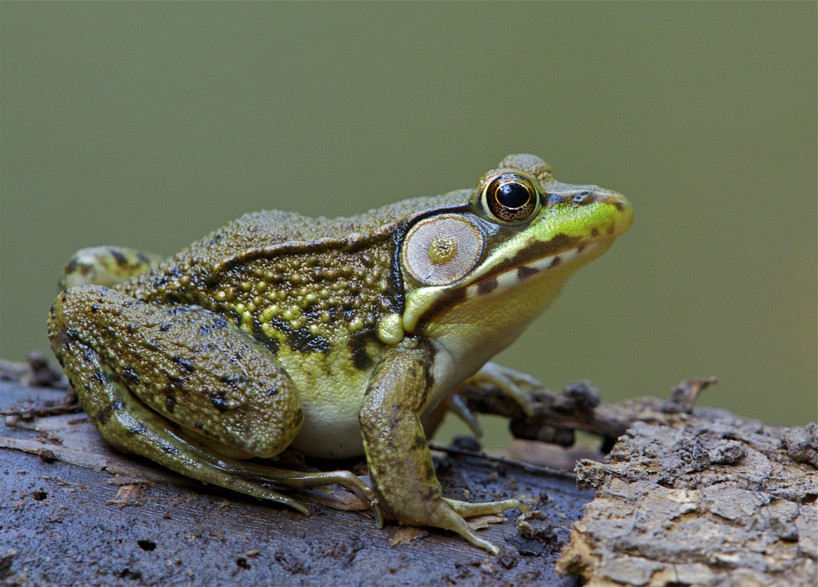

Zippy the Frog perched on the edge of the burrow as rain began to pound the forest floor. The river upstream swelled, and a sudden flood threatened the burrow’s safety. (Frogs can survive in flooded environments by holding onto submerged vegetation.) Zippy’s webbed feet allowed him to glide across the slick surface, leaping from one log to the next. (The webbing between frog toes increases surface area for better propulsion in water.)
He sensed the rising water with his ears, which also function as hearing organs sensitive to low-frequency vibrations. (Frogs use their tympanum to detect sound in both air and water.) The floodwater carried away the leaves that normally formed a protective layer around the burrow, but Zippy pushed them back with his tail. (The frog’s tail aids in swimming and balance.)
As the current intensified, Zippy leapt onto a floating branch and stayed there, clinging to its bark. The branch carried him safely above the rising water. (Frogs can use floating debris to escape rising waters.) When the flood passed, he returned to the burrow, where the young chorus frogs were still safe behind the thick reeds. (Reeds act as a natural dam, slowing floodwater.)
Zippy’s quick thinking and amphibious adaptations had once again protected the burrow from sudden environmental threats. (Frogs’ adaptability to both wet and dry conditions is crucial for survival in dynamic habitats.)
:)

